St. Paul Catholic School Middle School Supply List

RETURNING Middle School students: Sketchbooks, watercolor sets, rulers, calculators, Bibles, headphones, chargers, iPad covers, and many other supplies can be used/re-used and do not need to be replaced each year unless broken or lost.

NEW Middle School students must purchase all materials listed below.

MIDDLE SCHOOL (6th – 8th Grade)
10 Blue or Black pens
5 Red pens
36 #2 Ticonderoga Pencils or mechanical pencils
5 Highlighters, different colors
4 Black, fine-tip pens for outlining (suggested: Papermate
Flair or Sharpie “Pen”)
1 pair scissors
4 glue sticks
1 bottle Elmer’s liquid glue
1 large eraser
1 box colored pencils, set of at least 16
Optional: Markers and Watercolor set
1 ruler
4-6 packages index cards (3”x5”)
2 packages notebook paper (college ruled)
Sketchbook, spiral bound
3-Subject college-ruled spiral notebook
2 spiral college-ruled notebooks
1 ream copy paper
Texas Instruments, 30XS Multiview Scientific Calculator
1 Catholic Youth Bible, 4th Edition Saint Mary’s Press (cover
and tabs recommended)
1 Merrian-Webster Edition Spanish/English Dictionary
1 lightning charger for iPad (for home)
1 pair headphones (wired or wireless) (for school)
1-2 boxes tissues
1 container disinfecting wipes
1 crate or locker shelf that fits 12” opening
1 backpack (rolling bags discouraged)
PE clothes (St. Paul shirt & shorts w/ 5” inseam or longer)

Choose 1 of the following organizational systems:
Option A: (Highly Recommended)
1 accordion folder with at least 12 dividers
1 supply container for backpack

Option B:
1 large zip-up 3 ring binder
1 set of 8 pocket dividers or 6 3-hole pocket folders (different colors)
1 zipper pencil pouch

6th – 8th Grades: iPad cover with keyboard
- Ipad Cover with Keyboard- Any color.
7th & 8th Grades:
1 roll paper towels
1 box sandwich, quart, or gallon Ziplock bags
*Students are responsible for replenishing supplies throughout the year as needed.
*Don’t hesitate to reach out if you have any questions or need clarification on specific items.
*Your child will bring all supplies with them to Orientation on Tuesday, September 1st.

Middle School Supplies List: Helpful Hints
Here are some links/pictures to help you as you school shop.
Accordion Folder:

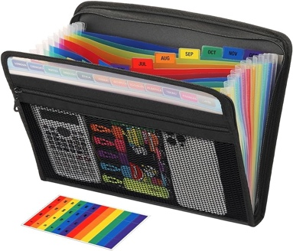
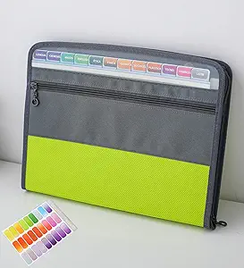

Another Key Supply is black outlining pens. We use these for many school projects, posters, and art assignments all year long. These should be fine tip, felt tip, and ideally, not bleed through paper. We suggest either of these (or an equivalent generic brand).
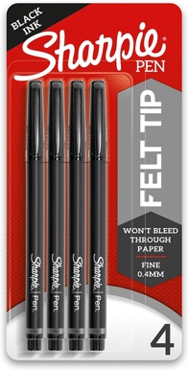
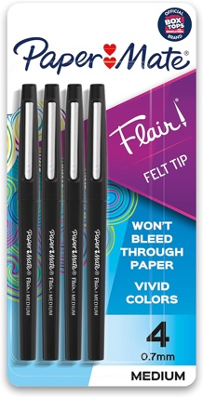

Locker Hints
Lockers will hold students’ extra supplies, textbooks, lunchbox, sweatshirt/jacket, etc. It is necessary to have something to divide the space. You can purchase locker shelves (such as the ones below) or we’ve even had creative parents build shelves out of wood or sturdy boxes. Just check to make sure that they will fit through a 12” opening and be able to support the weight of heavy books.

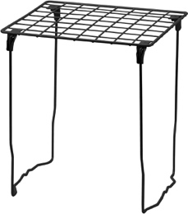
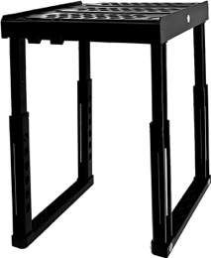

Locker Hints Continued
It is helpful to find a small crate/container/caddy or pencil box to organize art supplies as well. Most students keep their markers, colored pencil, watercolors, glue, and scissors in their locker, and it is hard to stay organized if those are loose.
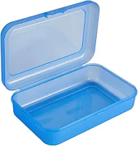
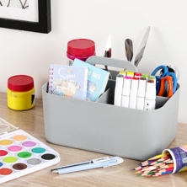
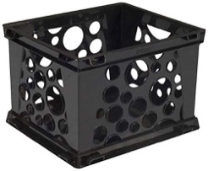

Decorations: Students are usually excited to decorate their locker. They are welcome to personalize them if they keep the following in mind.
- They will most likely switch lockers mid-year so they shouldn’t do more than they can move independently and efficiently.
- Everything needs to be attached with magnets – no tape or other adhesives
- Lockers are not locked, and things sometimes fall out if kids shut them “enthusiastically.” They shouldn’t put anything in their locker that they would be sad if it fell out and broke.

Middle School Bibles
This year, we are asking all middle school students to have a Bible for religion class. The idea is that they will use this Bible all three years of middle school and hopefully beyond. Any Catholic Bible could work. However, if you are purchasing one anyway, we are suggesting the Catholic Youth Bible from St. Mary’s Press (4th Edition). It has great features and is designed specifically for teens.

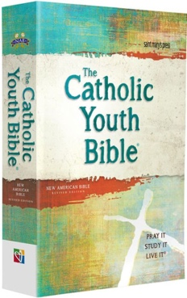

This Bible can be purchased from many different online stores and can probably even be found used. Here are some links to check out:

Amazon Barnes and Noble St. Mary’s Press

Middle School Bibles Continued

Because the idea is for the kids to have these Bibles for many years, we are highly recommending purchasing a cover. There are a lot of options on Amazon. Here is one that we purchased as a sample. We found that “Large” was the correct size.
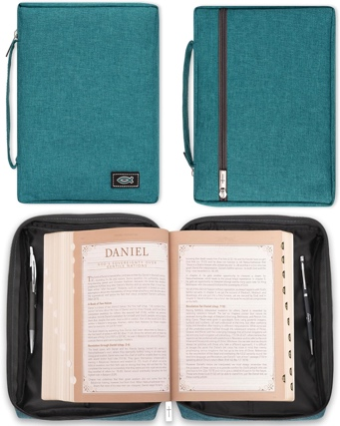

Bible Cover

One final consideration is to purchase Bible Tabs. These can make it easier to find specific books in the Bible efficiently. It is completely optional. Here is a link to an example. Make sure to get “Catholic Bible Tabs.”
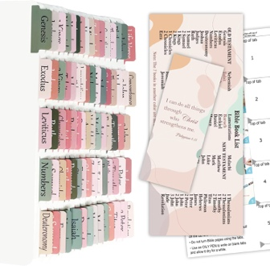

Bible Tabs

Middle School Spanish
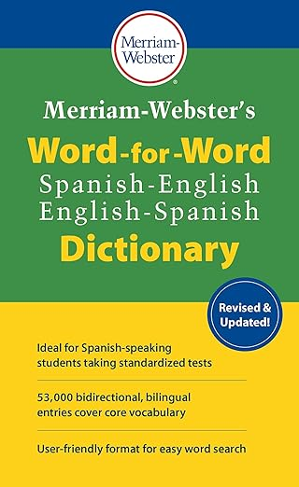

Middle School PE
Students must dress down for PE. They will wear a St. Paul shirt on top and athletic shorts that meet Relaxed Dress requirements on the bottom. Shorts must have at least a 5” inseam.

APPROVED BOTTOMS:
- Sweats
- Joggers
- 5-inch inseam shorts (or longer)

Here are some already approved shorts below:
Amazon 5”
Old Navy 5”
Amazon 5”
Unisex 5”
Nike 5”

APPROVED TOPS:
- Plain short or long-sleeved shirt
- Limit logos – no more than 2. If logos are present, no larger than 3”x3” (post-it note size)
- Saint Paul short or long-sleeved shirt
NOT APPROVED:
- Tank tops
- Shirts with sayings or images

NOT APPROVED:
- Biker or spandex shorts
- Leggings by themselves
- Shorts shorter than a 5 inch in-seam

i-Pad Cover Options
